White-Box Testing

Project: Employee Management System in C++

1. Statement Coverage

Definition
Statement coverage checks whether every executable statement of the program runs at least once.

Applied on Code
In this project, statement coverage is applied on:
- isValidName()
- inputPositiveIdWithBack()
- inputSalaryWithBack()
- addemp()
- searchEmpById()
- removeempById()
- editiEmp()
- DisplayallEmp()

Test Cases
Test Case ID | Function | Input / Scenario | Expected Output
SC-01 | isValidName() | Empty name | Invalid name
SC-02 | isValidName() | Name greater than 15 letters | Invalid name
SC-03 | isValidName() | Ali123 | Invalid name
SC-04 | isValidName() | Ali | Valid name
SC-05 | inputPositiveIdWithBack() | abc | Characters not allowed
SC-06 | inputPositiveIdWithBack() | -5 | Negative ID not allowed
SC-07 | inputPositiveIdWithBack() | 5 | ID accepted
SC-08 | inputSalaryWithBack() | abc | Characters not allowed
SC-09 | inputSalaryWithBack() | -2000 | Negative salary not allowed
SC-10 | inputSalaryWithBack() | 30000 | Salary accepted
SC-11 | addemp() | ID 1, Name Ali, Salary 30000 | Employee added successfully
SC-12 | searchEmpById() | Existing ID | Employee found
SC-13 | searchEmpById() | Non-existing ID | Employee not found
SC-14 | removeempById() | Existing ID | Employee deleted
SC-15 | editiEmp() | Update name and salary | Updated details shown
SC-16 | DisplayallEmp() | Employees available | All employees displayed

Result
All important executable statements are executed at least once.
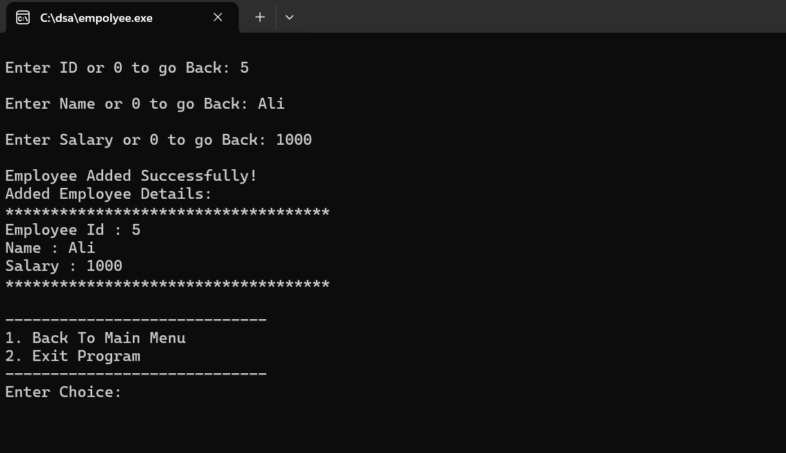
Statement Coverage Result: All selected major statements covered.

2. Branch Coverage

Definition
Branch coverage checks whether every true and false branch of decision statements is executed.

Applied on Code
Branch coverage is applied on:
- if
- else if
- else
- while
- switch
Test cases
Test Case ID | Condition / Branch | Input / Scenario | Expected Output
BC-01 | name.length() == 0 true | Empty name | Invalid
BC-02 | name.length() == 0 false | Ali | Continue checking
BC-03 | name.length() > 15 true | Long name | Invalid
BC-04 | name.length() > 15 false | Ali | Continue checking
BC-05 | !isalpha(name[i]) true | Ali123 | Invalid
BC-06 | !isalpha(name[i]) false | Ali | Valid
BC-07 | cin.fail() true | abc as ID | Invalid ID
BC-08 | id < 0 true | -3 | Negative ID rejected
BC-09 | Valid ID branch | 5 | ID accepted
BC-10 | start == NULL true | Empty list | No employee data
BC-11 | start == NULL false | List has data | Continue operation
BC-12 | ID match true | Search existing ID | Employee found
BC-13 | ID match false | Search wrong ID | Employee not found
BC-14 | Switch case 1 | Choice 1 | Add employee
BC-15 | Switch case 2 | Choice 2 | Display employee
BC-16 | Switch case 3 | Choice 3 | Search employee
BC-17 | Switch case 4 | Choice 4 | Delete employee
BC-18 | Switch case 5 | Choice 5 | Edit employee
BC-19 | Switch case 6 | Choice 6 | Exit program

Result
All true and false branches are covered.
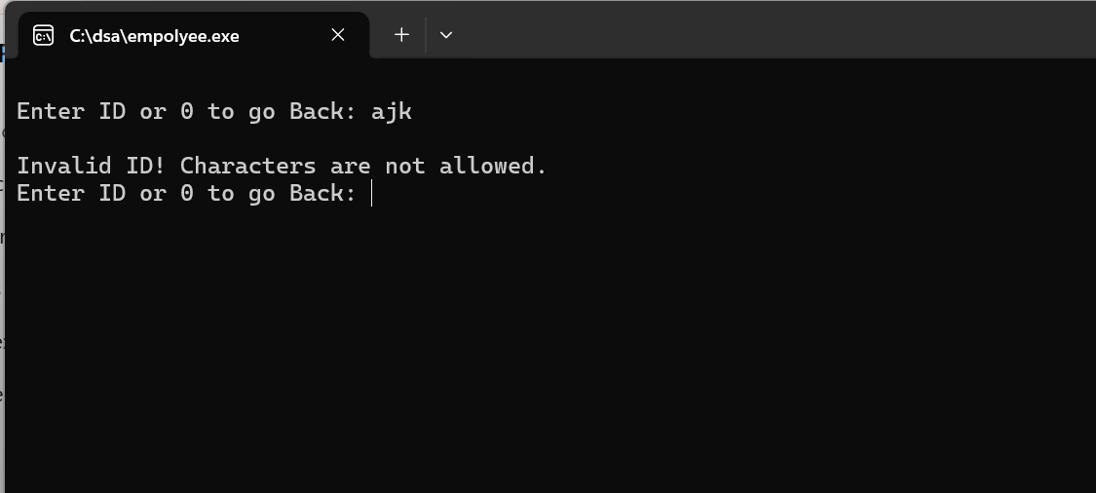

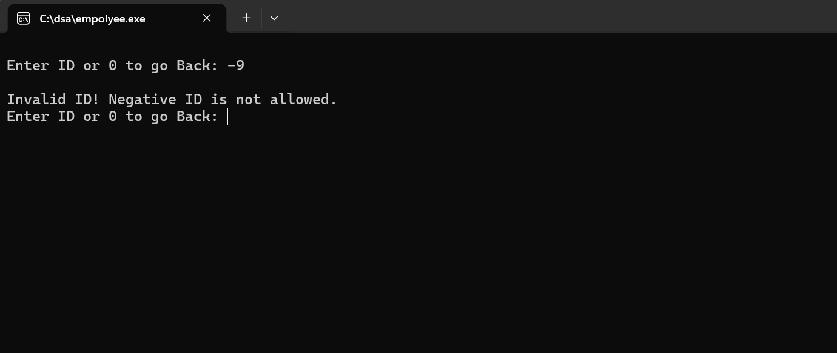
Branch Coverage Result: All identified branches were successfully tested.

3. Condition Coverage

Definition
Condition coverage checks each individual Boolean condition with both true and false values.

Important Conditions
Condition ID | Condition | True Input | False Input
C1 | name.length() == 0 | Empty name | Ali
C2 | name.length() > 15 | Long name | Ali
C3 | !isalpha(name[i]) | Ali123 | Ali
C4 | cin.fail() | abc | 5
C5 | id < 0 | -3 | 5
C6 | sal < 0 | -2000 | 30000
C7 | ans == 'Y' || ans == 'y' | Y | N
C8 | start == NULL | Empty list | List has data
C9 | p != NULL | Node exists | End of list
C10 | ch < 1 || ch > 6 | 0 or 7 | 1 to 6

Test Cases
Test Case ID | Input / Scenario | Condition Covered | Expected Output
CC-01 | Empty name | C1 true | Invalid
CC-02 | Ali | C1 false, C2 false, C3 false | Valid
CC-03 | Long name | C2 true | Invalid
CC-04 | Ali123 | C3 true | Invalid
CC-05 | ID abc | C4 true | Invalid
CC-06 | ID -3 | C5 true | Invalid
CC-07 | ID 5 | C4 false, C5 false | Valid
CC-08 | Salary -2000 | C6 true | Invalid
CC-09 | Salary 30000 | C6 false | Valid
CC-10 | Answer Y | C7 true | Update allowed
CC-11 | Answer N | C7 false | Update skipped
CC-12 | Empty list | C8 true | No data
CC-13 | Existing employee | C8 false, C9 true | Operation continues
CC-14 | Menu choice 7 | C10 true | Invalid choice
CC-15 | Menu choice 3 | C10 false | Search selected

Result
Each important condition is tested with true and false values.
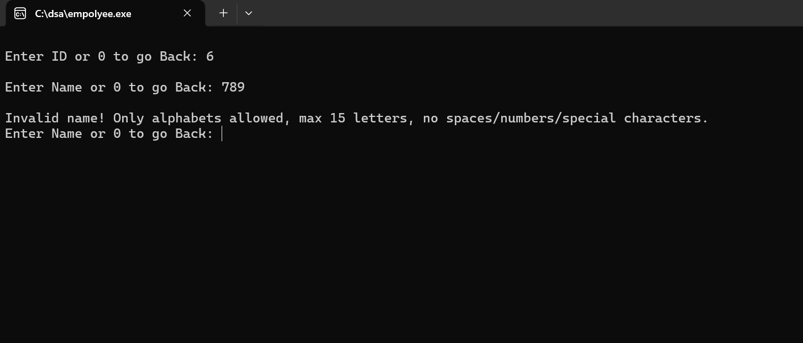
Condition Coverage Result: All major conditions were evaluated using both true and false outcomes.

4. Path Coverage

Definition
Path coverage checks different possible execution paths of a function from start to end.
Path Coverage for isValidName()
Path ID | Input | Path Covered | Expected Output
PC-01 | Empty name | Start → empty check true → return false | Invalid
PC-02 | Long name | Start → empty false → length > 15 true → return false | Invalid
PC-03 | Ali123 | Start → valid length → loop → non-alpha true → return false | Invalid
PC-04 | Ali | Start → valid length → loop all alphabet → return true | Valid



Path Coverage for searchEmpById()
Path ID | Scenario | Path Covered | Expected Output
PC-05 | Empty list | Start → start == NULL → return | No employee data
PC-06 | ID found at first node | Start → list not empty → first ID matched → display → return | Employee found
PC-07 | ID found after first node | Start → first ID not matched → next ID matched → display → return | Employee found
PC-08 | ID not found | Start → traverse complete list → not found | Employee not found

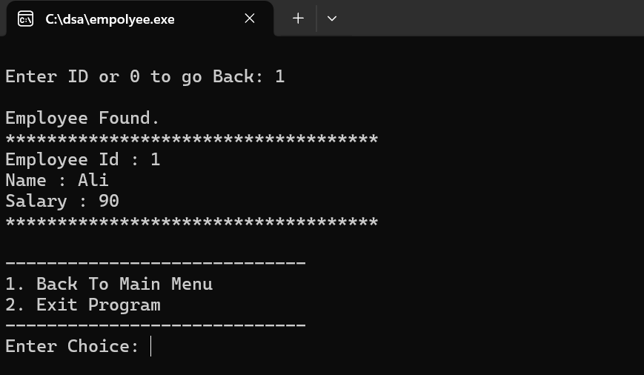
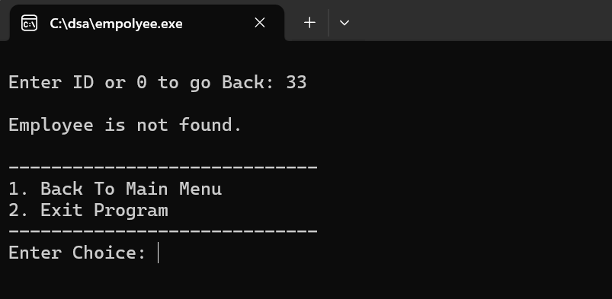

Path Coverage for removeempById()
Path ID | Scenario | Path Covered | Expected Output
PC-09 | Empty list | Start → start == NULL → return | No employee data
PC-10 | Delete first employee | Start → first ID matched → delete first node → return | Deleted
PC-11 | Delete second/last employee | Start → first not matched → loop → next matched → delete → return | Deleted
PC-12 | ID not found | Start → traverse list → no match → not found | Employee not found
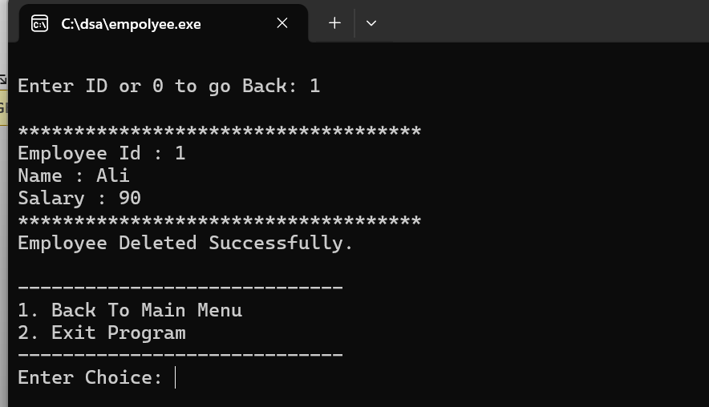

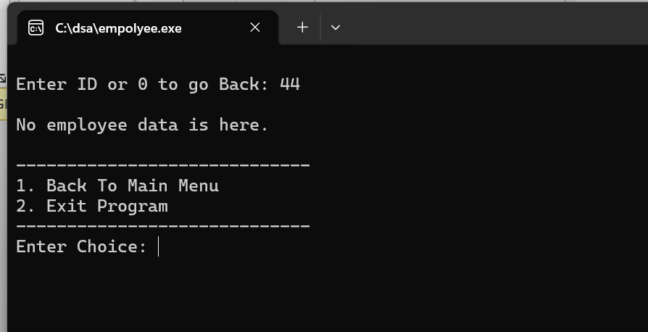

Result
Important independent paths of validation, search, and delete functions are covered.
Path Coverage Result: High / Practical 100%

5. Loop Testing

Definition
Loop testing checks loops with zero, one, two, and multiple iterations.
Loops in Project
Loop ID | Function | Loop Purpose
L1 | isValidName() | Check each character
L2 | inputPositiveIdWithBack() | Repeat until valid ID
L3 | inputSalaryWithBack() | Repeat until valid salary
L4 | inputYesNo() | Repeat until Y/N
L5 | isIdExist() | Traverse linked list
L6 | searchEmpById() | Traverse linked list
L7 | removeempById() | Traverse for deletion
L8 | DisplayallEmp() | Display all employees
L9 | main() | Menu repetition

Test Cases
Test Case ID | Loop | Scenario | Iteration Type | Expected Output
LT-01 | isValidName() | Empty name | 0 iteration | Invalid
LT-02 | isValidName() | A | 1 iteration | Valid
LT-03 | isValidName() | Ali | Multiple iterations | Valid
LT-04 | ID input loop | 5 | 1 iteration | Accepted
LT-05 | ID input loop | abc, then 5 | 2 iterations | Invalid then accepted
LT-06 | ID input loop | abc, -3, 5 | Multiple iterations | Invalid until valid
LT-07 | Salary input loop | 30000 | 1 iteration | Accepted
LT-08 | Salary input loop | abc, -100, 30000 | Multiple iterations | Invalid until valid
LT-09 | inputYesNo() | Y | 1 iteration | Accepted
LT-10 | inputYesNo() | x, then N | 2 iterations | Invalid then accepted
LT-11 | Linked list traversal | Empty list | 0 iteration | No data / false
LT-12 | Linked list traversal | One employee | 1 iteration | Found/displayed
LT-13 | Linked list traversal | Three employees | Multiple iterations | Traversal completed
LT-14 | Main menu loop | Choice 6 directly | 1 iteration | Exit
LT-15 | Main menu loop | Choices 1, 2, 6 | Multiple iterations | Add, display, exit

Result
Loops are tested for zero, one, two, and multiple iterations.

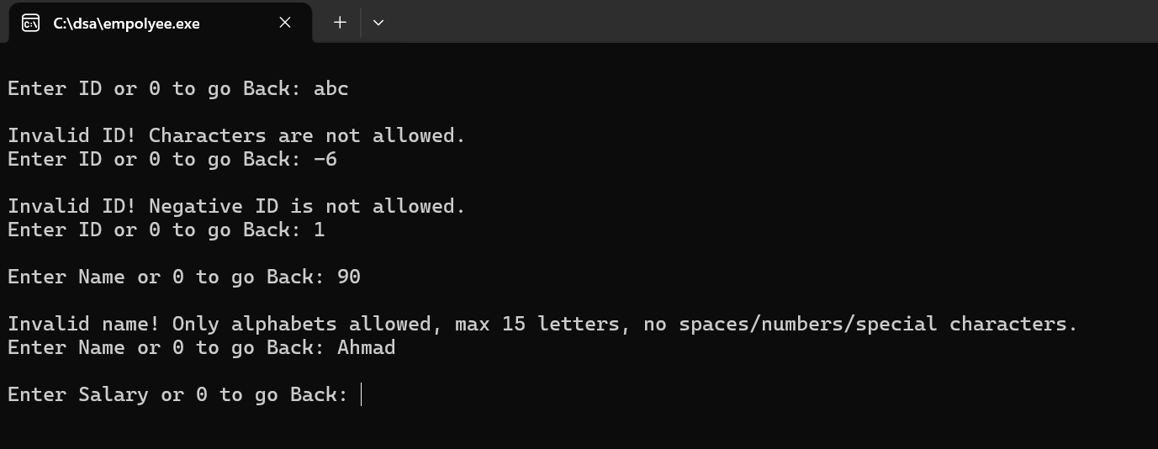
Loop Testing Result: 100%

6. Basis Path Testing

Definition
Basis path testing identifies independent paths using cyclomatic complexity.
Formula:
Cyclomatic Complexity = Predicate Nodes + 1

Basis Path Testing for removeempById()

Predicate Nodes
Predicate No. | Decision
P1 | if (start == NULL)
P2 | if (id == p->getdata().getid())
P3 | while (p->getnext() != NULL)
P4 | if (id == p->getnext()->getdata().getid())
Cyclomatic Complexity:
V(G) = P + 1
V(G) = 4 + 1
V(G) = 5



Independent Paths
Path ID | Scenario | Test Data | Expected Output
BP-01 | Empty list | Delete ID 1 from empty list | No employee data
BP-02 | Delete first node | List: ID 1, delete 1 | Employee deleted
BP-03 | Delete second node | List: ID 1, 2; delete 2 | Employee deleted
BP-04 | Delete last node after multiple traversal | List: ID 1, 2, 3; delete 3 | Employee deleted
BP-05 | ID not found | List: ID 1, 2; delete 5 | Employee not found

Basis Path Testing for editiEmp()

Predicate Nodes
Predicate No. | Decision
P1 | if (start == NULL)
P2 | while (p != NULL)
P3 | if (p->getdata().getid() == id)
P4 | if (ans == 'Y' || ans == 'y') for name
P5 | if (name == "0")
P6 | else if (!isValidName(name))
P7 | else if (isNameExistExceptCurrentId(name, id))
P8 | if (ans == 'Y' || ans == 'y') for salary
P9 | if (sal == 0)
Cyclomatic Complexity:
V(G) = P + 1
V(G) = 9 + 1
V(G) = 10
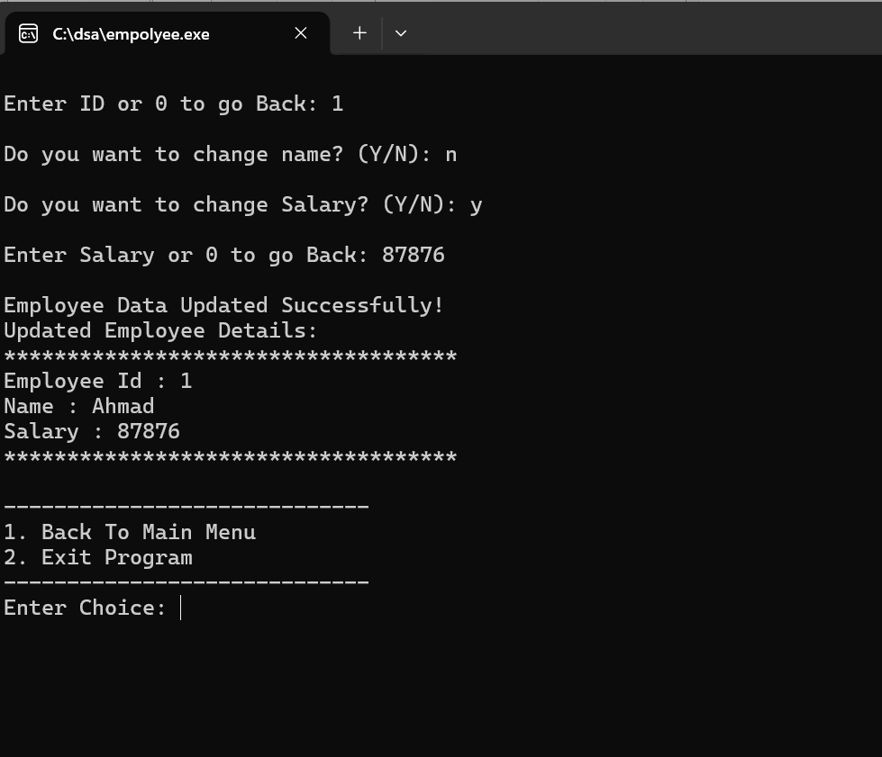
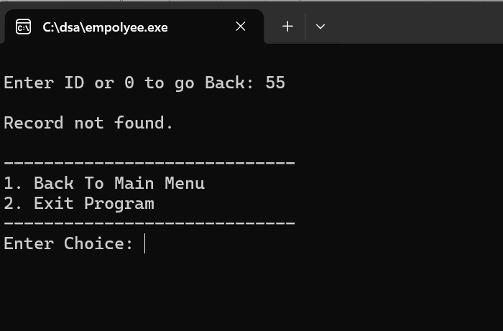

Independent Paths
Path ID | Scenario | Test Data | Expected Output
BP-06 | Empty list | Edit ID 1 from empty list | No Employee is here
BP-07 | ID not found | List has ID 1, edit ID 5 | Record not found
BP-08 | No update selected | Existing ID, Name: N, Salary: N | Same data saved again
BP-09 | Valid name update only | Y, new name Sara, Salary: N | Name updated
BP-10 | Name update cancelled | Y, name 0, Salary: N | Name update cancelled
BP-11 | Invalid name then valid | Y, Ali123, then Sara | Invalid then accepted
BP-12 | Duplicate name then valid | Y, existing name, then unique name | Duplicate rejected
BP-13 | Salary update only | Name: N, Salary: Y, 40000 | Salary updated
BP-14 | Salary update cancelled | Name: N, Salary: Y, 0 | Salary cancelled
BP-15 | Both name and salary updated | Y, Sara, Y, 50000 | Both updated

Result
Independent paths are tested according to cyclomatic complexity.
Basis Path Testing Result: Covered

